**Exercise 1: Control Structures**

**Table creation:**

CREATE TABLE Customers (

    CustomerID NUMBER PRIMARY KEY,

    Name VARCHAR2(100),

    DOB DATE,

    Balance NUMBER,

    LastModified DATE

);

ALTER TABLE Customers ADD IsVIP VARCHAR2(5) DEFAULT 'FALSE';

INSERT INTO Customers (CustomerID, Name, DOB, Balance, LastModified, IsVIP) VALUES

(1, 'Arun',    TO_DATE('1958-06-10', 'YYYY-MM-DD'), 15000, SYSDATE, 'FALSE'),

(2, 'Bharathi',TO_DATE('1968-09-15', 'YYYY-MM-DD'), 8000,  SYSDATE, 'FALSE'),

(3, 'Eswari',  TO_DATE('1950-01-25', 'YYYY-MM-DD'), 5000,  SYSDATE, 'FALSE'),

(4, 'Nithin',  TO_DATE('1980-03-12', 'YYYY-MM-DD'), 12000, SYSDATE, 'FALSE'),

(5, 'Shivani', TO_DATE('1995-12-01', 'YYYY-MM-DD'), 3000,  SYSDATE, 'FALSE');

SELECT * FROM Customers;

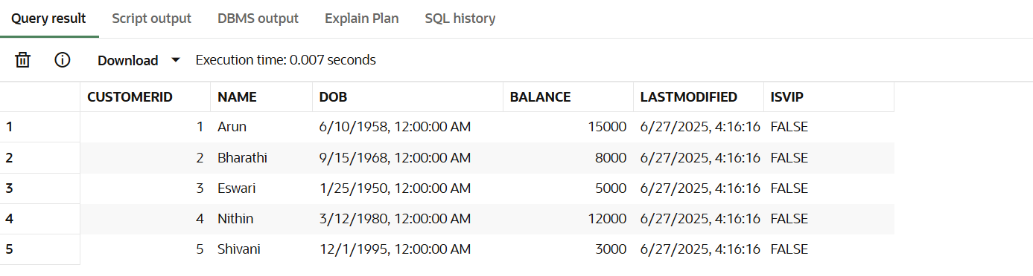

CREATE TABLE Loans (

    LoanID NUMBER PRIMARY KEY,

    CustomerID NUMBER,

    LoanAmount NUMBER,

    InterestRate NUMBER,

    StartDate DATE,

    EndDate DATE,

    FOREIGN KEY (CustomerID) REFERENCES Customers(CustomerID)

);

-- Insert into Loans

INSERT INTO Loans (LoanID, CustomerID, LoanAmount, InterestRate, StartDate, EndDate) VALUES

(201, 1, 100000, 6.5, SYSDATE - 5, SYSDATE + 15),  -- Arun (66, due soon)

(202, 2, 75000,  7.0, SYSDATE - 10, SYSDATE + 45), -- Bharathi (not senior)

(203, 3, 50000,  8.2, SYSDATE - 7, SYSDATE + 10),  -- Eswari (75, due soon)

(204, 4, 120000, 5.9, SYSDATE - 2, SYSDATE + 25),  -- Nithin (VIP, due soon)

(205, 5, 30000,  6.0, SYSDATE - 1, SYSDATE + 5);   -- Shivani (young, due soon)

SELECT * FROM Loans;

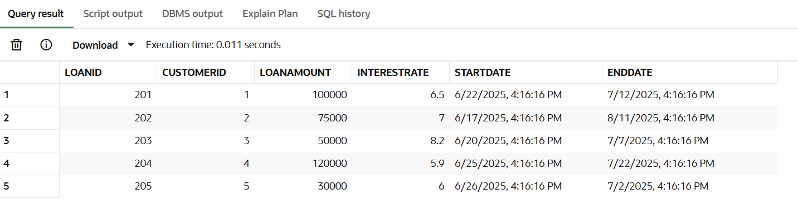

CREATE TABLE Accounts (

    AccountID NUMBER PRIMARY KEY,

    CustomerID NUMBER,

    AccountType VARCHAR2(20),

    Balance NUMBER,

    LastModified DATE,

    FOREIGN KEY (CustomerID) REFERENCES Customers(CustomerID)

);

INSERT INTO Accounts (AccountID, CustomerID, AccountType, Balance, LastModified) VALUES

(301, 1, 'Savings', 15000, SYSDATE),

(302, 2, 'Checking', 8000, SYSDATE),

(303, 3, 'Savings', 5000, SYSDATE),

(304, 4, 'Checking', 12000, SYSDATE),

(305, 5, 'Savings', 3000, SYSDATE);

SELECT * FROM Accounts;

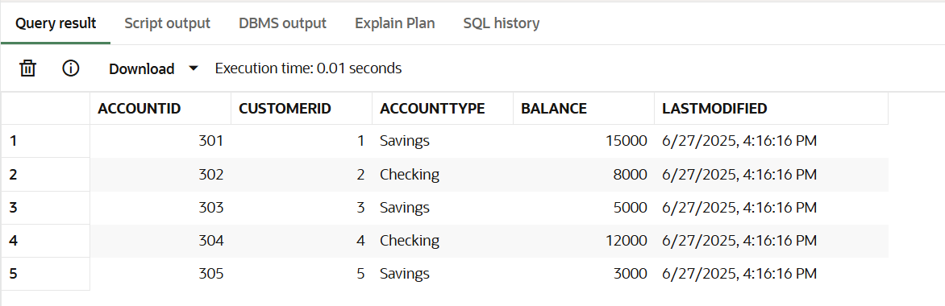

CREATE TABLE Employees (

    EmployeeID NUMBER PRIMARY KEY,

    Name VARCHAR2(100),

    Position VARCHAR2(50),

    Salary NUMBER,

    Department VARCHAR2(50),

    HireDate DATE

);

INSERT INTO Employees (EmployeeID, Name, Position, Salary, Department, HireDate) VALUES

(501, 'Kiran', 'HR Manager', 60000, 'HR', SYSDATE - 1500),

(502, 'Ravi', 'Tech Lead', 80000, 'Tech', SYSDATE - 1200);

SELECT * FROM Employees;

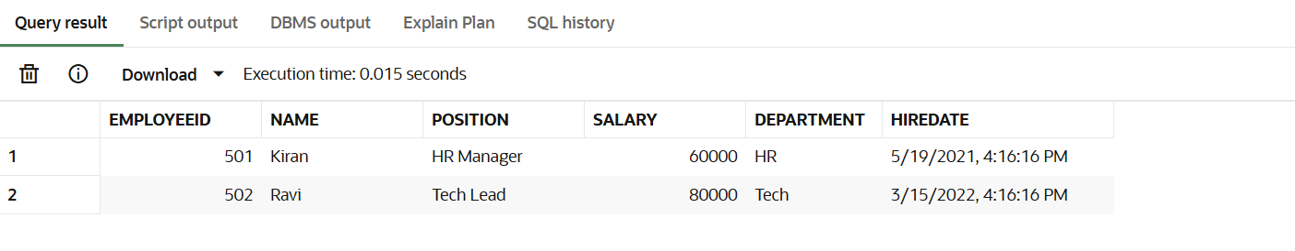

CREATE TABLE Transactions (

    TransactionID NUMBER PRIMARY KEY,

    AccountID NUMBER,

    TransactionDate DATE,

    Amount NUMBER,

    TransactionType VARCHAR2(10),

    FOREIGN KEY (AccountID) REFERENCES Accounts(AccountID)

);

INSERT INTO Transactions (TransactionID, AccountID, TransactionDate, Amount, TransactionType) VALUES

(401, 301, SYSDATE, 5000, 'Credit'),

(402, 302, SYSDATE, 2000, 'Debit'),

(403, 303, SYSDATE, 3000, 'Credit');

COMMIT;

SELECT * FROM Transactions;

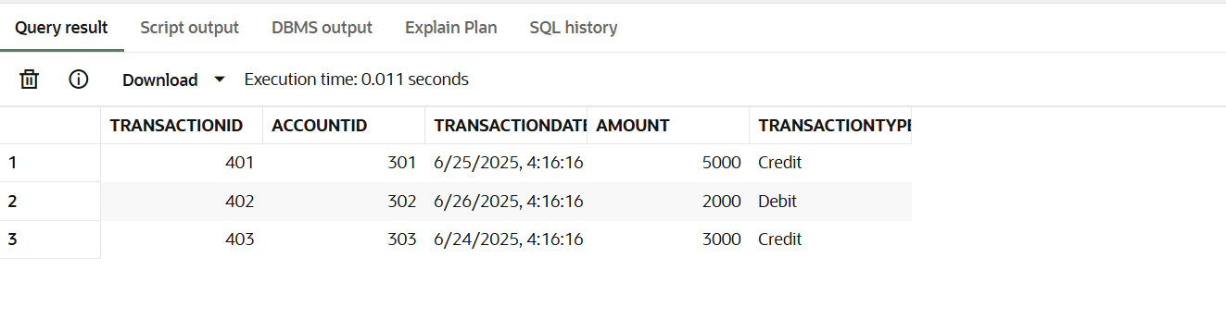

**Scenario 1:**

BEGIN

  FOR cust_rec IN (

    SELECT CustomerID

    FROM Customers

    WHERE FLOOR(MONTHS_BETWEEN(SYSDATE, DOB) / 12) > 60

  ) LOOP

    UPDATE Loans

    SET InterestRate = InterestRate - 1

    WHERE CustomerID = cust_rec.CustomerID;

    UPDATE Customers

    SET LastModified = SYSDATE

    WHERE CustomerID = cust_rec.CustomerID;

  END LOOP;

  COMMIT;

  DBMS_OUTPUT.PUT_LINE('1% interest discount applied to customers aged above 60.');

END;

/

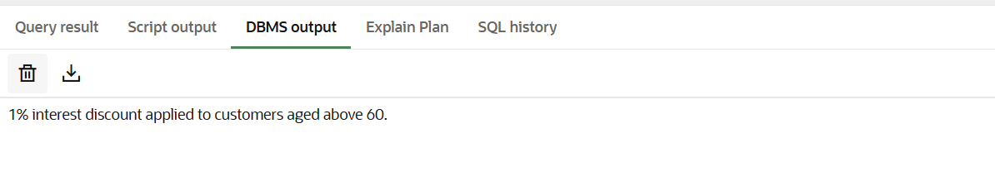

SELECT * FROM Loans;

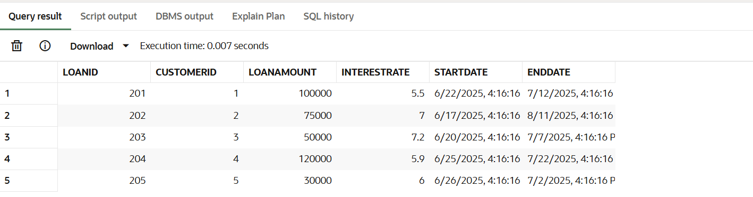

**Scenario 2:**

BEGIN

  FOR cust_rec IN (

    SELECT CustomerID

    FROM Customers

    WHERE Balance > 10000

  ) LOOP

    UPDATE Customers

    SET IsVIP = 'TRUE',

        LastModified = SYSDATE

    WHERE CustomerID = cust_rec.CustomerID;

  END LOOP;

  COMMIT;

  DBMS_OUTPUT.PUT_LINE('VIP status updated for customers with balance over ₹10,000.');

END;

/

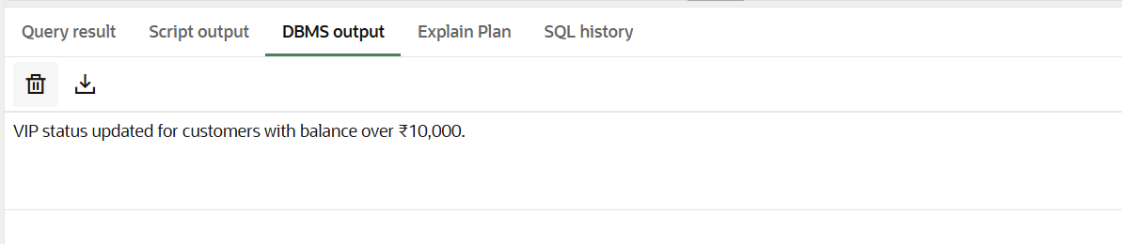

SELECT * FROM Customers;

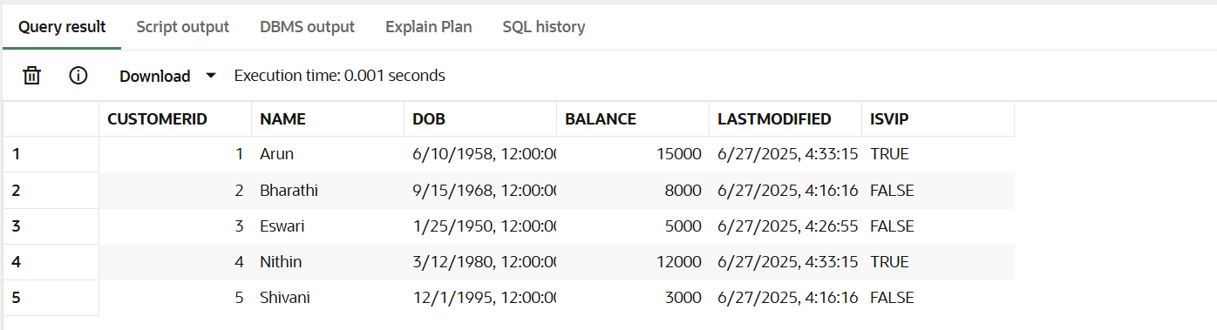

**Scenario 3:**

DECLARE

  CURSOR due_loans IS

    SELECT L.LoanID, C.Name, C.Email, L.DueDate

    FROM Loans L

    JOIN Customers C ON L.CustomerID = C.CustomerID

    WHERE L.DueDate BETWEEN SYSDATE AND SYSDATE + 30;

  v_loan_id Loans.LoanID%TYPE;

  v_name Customers.Name%TYPE;

  v_email Customers.Email%TYPE;

  v_due_date Loans.DueDate%TYPE;

BEGIN

  OPEN due_loans;

  LOOP

    FETCH due_loans INTO v_loan_id, v_name, v_email, v_due_date;

    EXIT WHEN due_loans%NOTFOUND;

    DBMS_OUTPUT.PUT_LINE('Reminder: Dear ' || v_name ||

                         ', your loan (ID: ' || v_loan_id ||

                         ') is due on ' || TO_CHAR(v_due_date, 'DD-Mon-YYYY') ||

                         '. Kindly ensure timely payment.');

  END LOOP;

  CLOSE due_loans;

END;

/

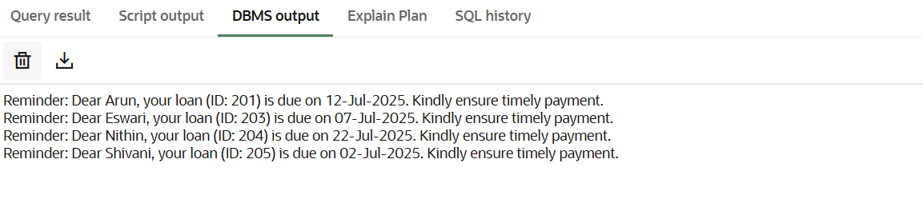

SELECT L.LoanID, L.CustomerID, C.Name, L.EndDate

FROM Loans L

JOIN Customers C ON C.CustomerID = L.CustomerID

WHERE L.EndDate BETWEEN SYSDATE AND SYSDATE + 30;

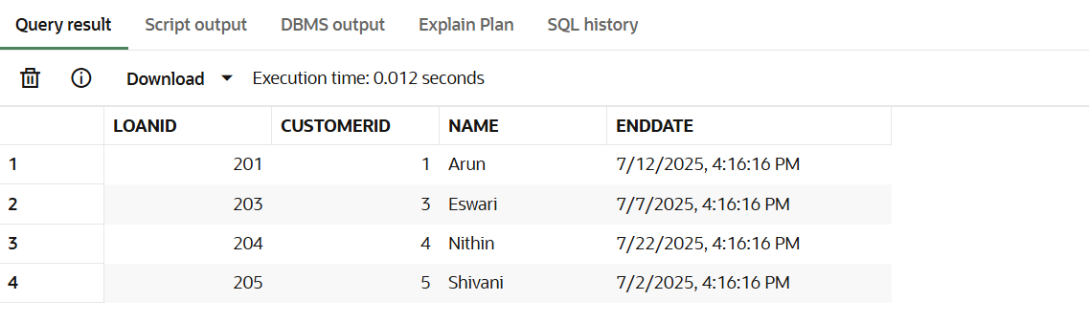

**Exercise 3: Stored Procedures**

**Scenario 1:**

CREATE OR REPLACE PROCEDURE ProcessMonthlyInterest IS

BEGIN

  UPDATE Accounts

  SET Balance = Balance + (Balance * 0.01),

      LastModified = SYSDATE

  WHERE AccountType = 'Savings';

  COMMIT;

  DBMS_OUTPUT.PUT_LINE('1% interest applied to all savings accounts.');

END;

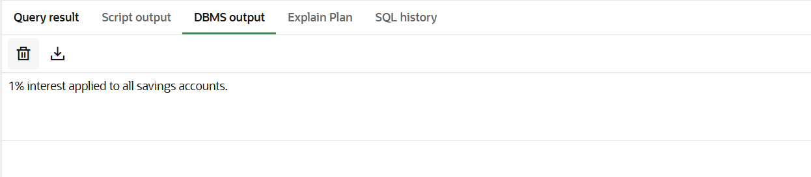

SELECT * FROM Accounts;

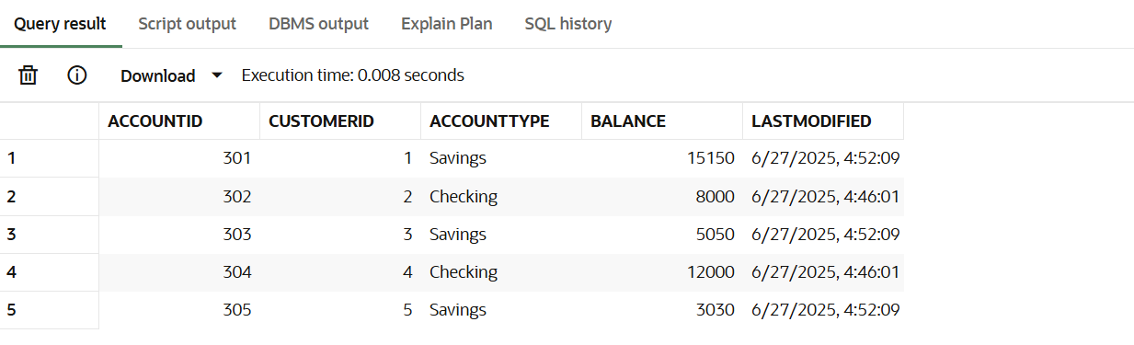

**Scenario 2:**

CREATE OR REPLACE PROCEDURE UpdateEmployeeBonus (

  p_dept IN VARCHAR2,

  p_bonus_percent IN NUMBER

) IS

BEGIN

  UPDATE Employees

  SET Salary = Salary + (Salary * p_bonus_percent / 100)

  WHERE Department = p_dept;

  COMMIT;

  DBMS_OUTPUT.PUT_LINE('Bonus of ' || p_bonus_percent || '% applied to ' || p_dept || ' department.');

END;

/

BEGIN

  UpdateEmployeeBonus('Tech', 10);

END;

/

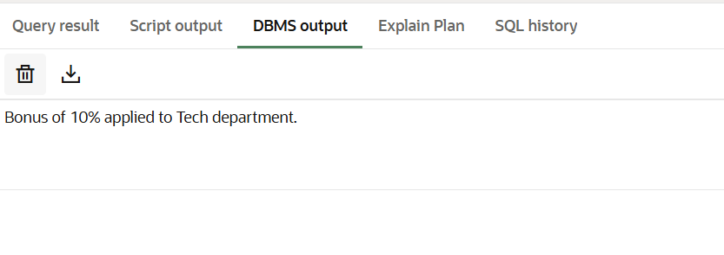

SELECT * FROM Employees WHERE Department = 'Tech';

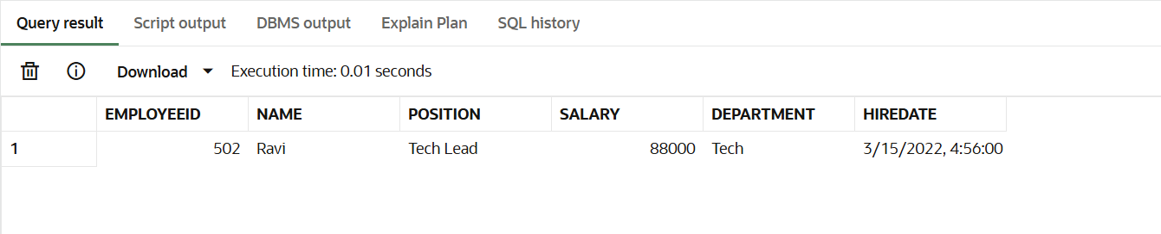

**Scenario 3:**

CREATE OR REPLACE PROCEDURE TransferFunds (

  p_from_account IN NUMBER,

  p_to_account   IN NUMBER,

  p_amount       IN NUMBER

) IS

  v_balance NUMBER;

BEGIN

  SELECT Balance INTO v_balance

  FROM Accounts

  WHERE AccountID = p_from_account;

  IF v_balance < p_amount THEN

    RAISE_APPLICATION_ERROR(-20001, 'Insufficient balance in source account.');

  END IF;

  UPDATE Accounts

  SET Balance = Balance - p_amount,

      LastModified = SYSDATE

  WHERE AccountID = p_from_account;

  UPDATE Accounts

  SET Balance = Balance + p_amount,

      LastModified = SYSDATE

  WHERE AccountID = p_to_account;

  COMMIT;

  DBMS_OUTPUT.PUT_LINE('₹' || p_amount || ' transferred from Account ' || p_from_account || ' to Account ' || p_to_account);

END;

/

BEGIN

  TransferFunds(301, 303, 2000);

END;

/

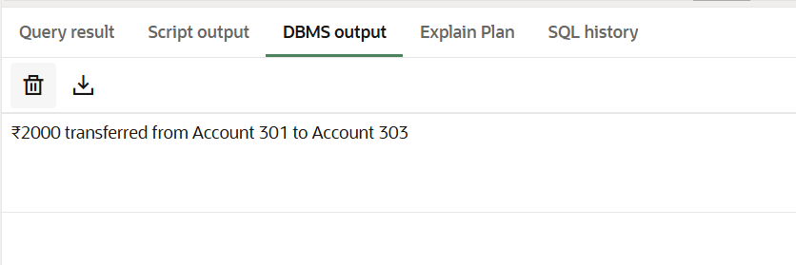

SELECT * FROM Accounts;

